Donald Tucker

[donald.tucker@lmco.com](mailto:donald.tucker@lmco.com)

Industrial Engineer with manufacturing experience applying lean principles in process improvement initiatives, cost savings estimates, time studies, capacity analysis, production work schedules, production rate modifications, staffing requirements, and production metrics.

**Skills**

Python, SQL, Tableau, Business Objects, Power Query, Exploratory Data Analysis, Regression, Machine Learning, Process Improvement, Capacity analysis

**Experience**

### Lockheed martin

### 11/2022 – Present

## Industrial Engineer Mgr, Lockheed martin- Aero F35

Manager leading a team of Industrial Engineers to develop metrics, data analytics, process improvement opportunities, resources allocation, and constraint mitigation plans.

### 10/2019 – 11/2022

## Industrial Engineer Asc Mgr, Lockheed martin- Aero F35

IE Asc Manager leading team of production floor Industrial Engineers to develop metrics, data analytics, process improvement opportunities, resources allocation, and constraint mitigation plans.

### 10/2017 – 10/2009

## Industrial Engineer Stf - Industrial Engineer Asc, Lockheed martin- Aero F35

J850 Technical Lead Industrial Engineer role leading the integration of functional IE solutions by analyzing and developing production plans and monitoring production health metrics.

**Education**

### 5/2012

MS Industrial Engineering, New Mexico State University

### 12/2008

BS Industrial engineering, University of texas at el Paso

**[](https://www.credly.com/badges/11760d13-cb60-4ca7-9bdf-5838e6f6cf69/public_url)**[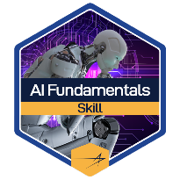](https://www.credly.com/badges/e144a08a-345f-4d2b-baf8-1c9d7fa99be6/public_url)[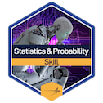](https://www.credly.com/badges/ea206568-8527-4fcc-b3d3-d361136657b7/public_url)**[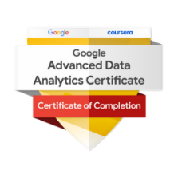](https://www.credly.com/badges/837f95d6-e710-4c2f-a9e9-bd9ab3888777/public_url)Certifications**

* **AI Fundamentals Skills** [**Badge**](https://www.credly.com/badges/e144a08a-345f-4d2b-baf8-1c9d7fa99be6/public_url) **and Practitioner** [**Badge**](https://www.credly.com/badges/11760d13-cb60-4ca7-9bdf-5838e6f6cf69/public_url)
* **Google Advanced Data Analytics** [**Certificate**](https://www.credly.com/badges/837f95d6-e710-4c2f-a9e9-bd9ab3888777/public_url)
* **Statistics and Probability for Python - LM Skills** [**Badge**](https://www.credly.com/badges/ea206568-8527-4fcc-b3d3-d361136657b7/public_url)

**Software**

Business Objects, SAP, ECM, MAP, CAPP, ETS, MATLAB, Solidworks, Minitab, Process Simulator, Pro/Engineer, IntelliCad, DraftSight, Qlikview, Tableau ([Portfolio](https://public.tableau.com/app/profile/donald.tucker)), SQL, Python, HTML, CSS